Abstract for the Structural Biology and Molecular Biophysics Workshop

Jeffrey J. Lovelaceª, Carol Kolarª, Reinhard Pahl^{b}, Keith Brister^{b} and Gloria E. O. Borgstahl^{a*}

ªEppley Institute for Cancer Research and Allied Diseases, Omaha, NE., ^{b}BioCARS - The University of Chicago, Argonne, IL 60439, USA, *E-mail: gborgstahl@unmc.edu

The abstract must be submitted by Aug 5, 2022 to be eligible for a poster prize. If you have difficulty uploading the abstract via the email provided web link then email it to jlovelace@unmc.edu.

Title should be centered and bold in Times New Roman 14. Authors should be listed with superscript lowercase letters to distinguish their affiliation (^{a-z}). If there is only one affiliation then no superscripts are needed. The authors list should use Times New Roman 10. The presenting author should be bold and the correspondence author should have a superscript asterisk (*) after their name. If there is only one author then no asterisk is required.

The list of affiliation should be in Italics Times New Roman 10. When there is more than one affiliation then each affiliation should be prepended with the appropriate superscripted lowercase letter. The last entry in the affiliation list should be the email of the corresponding author. If an asterisk was used in the author list then one should be prepended, for example: *Email: instead of Email:

The body of the abstract should be in Times New Roman 12. Paragraphs are not indented. Paragraphs should be separated by an empty line. The page margins are 1 inch on each side. If references are need they should follow the journal Nature’s style for reference formatting. References are each numbered, ordered sequentially as they appear in the text, methods summary, tables, boxes, figure legends, online-only methods. When cited in the text, reference numbers are superscript, not in brackets unless they are likely to be confused with a superscript number. The individual references should be shown as a superscripted numbered list at the bottom of the abstract in Times New Roman 10.

Multiple color figures can be included. Figures should be referenced as seen Fig. 1 or as shown in Fig. 1a. The figure legend should be Arial Size 10 Bold.

The entire abstract must fit on one page with in the 1 in. margin boundaries.

Anything else not covered in this example can be formatted as deemed necessary by the author.
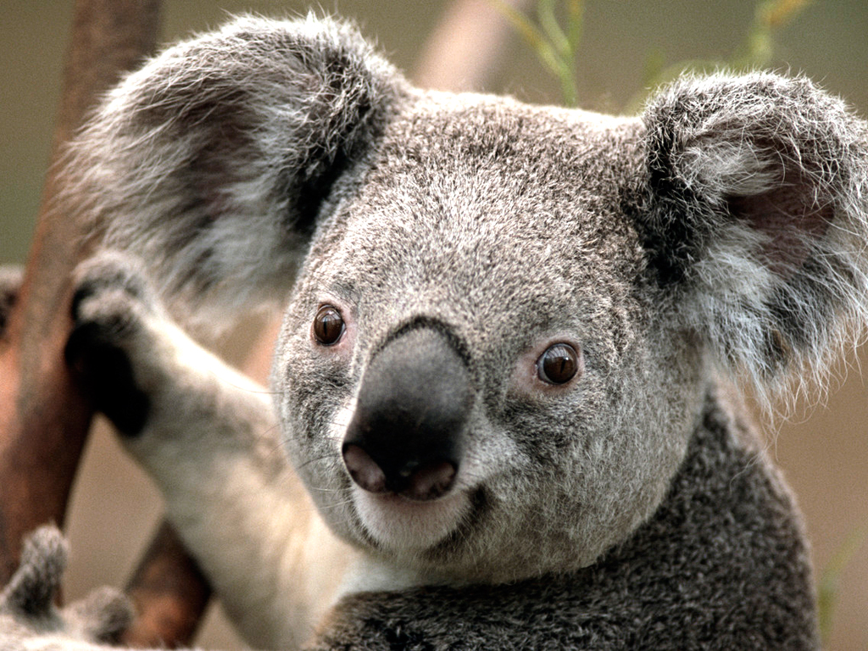

Figure 1: Koala Bear

